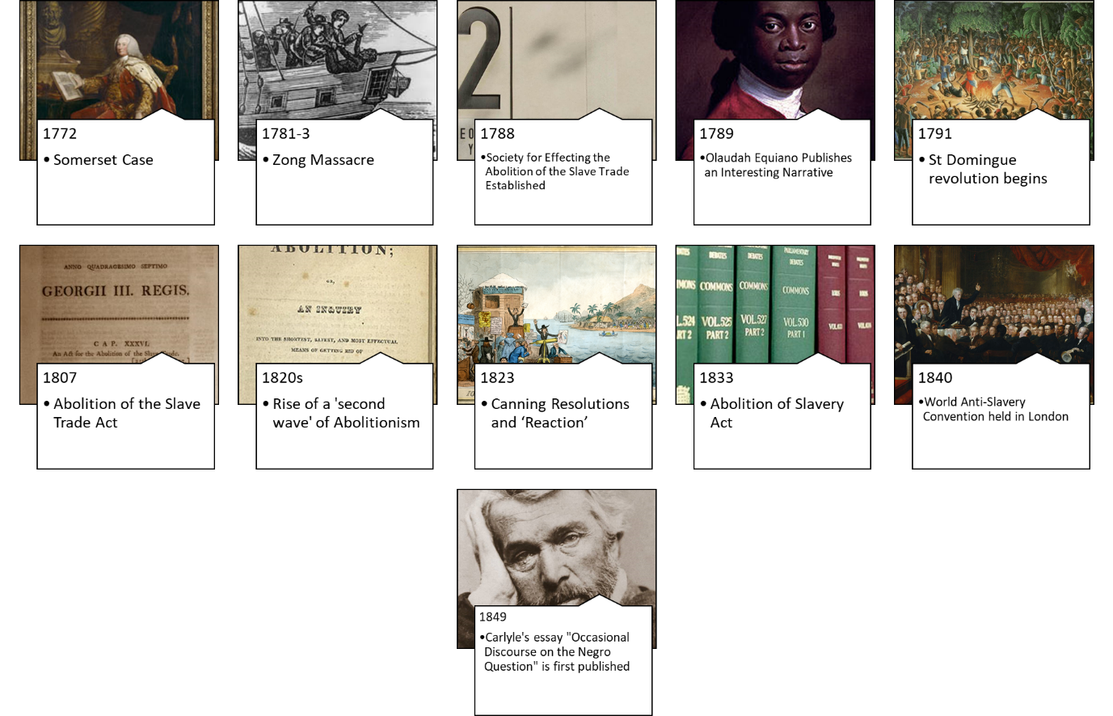
3. When did British public opinion against Slavery reach a ‘tipping point’?

When encountering a source, we can ask the following questions:
1. Provenance: What type of source is it? Who produced it and why? Does this make it a more or a less reliable source of evidence of ‘British Public Opinion on Slavery’? Why?
2. What does the source say and what does it reveal of public opinion towards Slavery at the time? (*which ‘public’?)
3. How valuable (revealing + reliable) is the source as evidence of Public Opinion towards Slavery?

When encountering an event, we should ask the following questions:
1. What could the event reveal of public opinion towards Slavery at the time? (*which ‘public’?)
2. How confident can we be of this?

1772 Somerset Case & Long’s Reply
Source A : Edward Long, Candid reflections upon the judgement lately awarded by the Court of King’s Bench in Westminster Hall on what is commonly called The Negroe Cause by a Planter, (London: t. Lowndes and Co., 1772)
THE invention of printing (if I mistake not) has been ascribed to a soldier , of gunpowder to a priest ; perhaps the longitude may be discovered by a taylor ; but the art of washing the Black-a-moor white was happily reserved for a lawyer: the thing that Solomon thought impossible when he said, “Can the Æthiop change “his skin?” What the wise Æsop esteemed a prodigy in nature; has, in the present wonder-working age, ceased any longer to be miraculous.
To conclude: I hope, while I am pleading the cause of the injured planters , I shall not be misunderstood to stand forth a champion for slavery. I am no stranger to the import L of the word; but am satisfied in my own mind, that our colony Negroes do not feel those hardships under their servitude, which have here been usually and undistinguishingly attributed to that vague term. As a friend to mankind, I sincerely wish that useful class to enjoy freedom, in a reasonable extent ; as a friend to my country, I cannot wish them set loose into that latitude of emancipation, which threatens injury to both. How far the late judicial sentence may be consistent with the spirit of English law , I will not take upon me to determine; sure I am, that it cannot be made compatible with the spirit of English commerce.

Q1. How much can we infer from the fact that the case of James Somerset was brought to Mansfield in 1772?
Q2. How much can we infer about British public opinion from Long’s response?
Q3. What questions may we want to ask of the source before we securely make inferences from it about British public opinion?

1781-3 Zong Massacre
The killing of more than 130 African slaves by the crew of the British slave ship on and in the days following 29 November 1781. Enslaved persons were murdered (being thrown overboard) in order to claim insurance payments. Such everyday brutality was typical of the system. However when the insurers refused to pay out to the ship's owners, the resulting court cases instigated some public horror at the system in Britain.

1787 Society for Effecting the Abolition of the Slave Trade Established

A British abolitionist group, formed on 22 May 1787, by twelve men who gathered together at a printing shop in East London. They were motivated by a christian belief in the wrongs of trading in human beings.

1789 Olaudah Equiano Publishes an Interesting Narrative

Written by a noted abolitionist and formerly enslaved man, the book gives both a powerful biographical account of his own fight for emancipation, as well as a strong moral argument against the Slavery as an institution. One of the first widely read slave narratives, it's success reflected a sympathy for abolitionism within Britain at the time.

1791 St Domingue revolution begins
The policy of establishing a great part of the force in
this country; of Blacks commanded by White Officers,
appears so necessary in my Opinion, that I am
anxious to lose no time in recommending it to His
Majesty’s Ministers, to take it into the serious
Consideration, and to direct the Execution of it, on
such principles, as they may judge to be most applicable
to attain the Object in View…
Or if it that should fail [of enlisting free Afro-Caribbean men into a Caribbean army], there remains but another
method, that of procuring the men from Africa; which
if done should be managed with great Precaution
by using means from the first outset, to attach them
to our Interest, and to gain their alliance from good [missing text]
and the inducements offer’d, previous to any other
engagements.
Source B: In 1794 the commander of British forces on Jamaica, General Vaughan wrote an urgent letter to the Secretary of War in London. He suggested that the British should raise an army to fight in the Caribbean.
- Why could the Commander of British Forces on Jamaica be so concerned about his ability to keep peace in 1794?
- What could he mean by recruiting soldiers by ‘another method’?
- What does Vaughan’s suggestion that this method should be ‘managed with great precaution’ reveal about public opinion on Slavery at the time?
- How reliable is such an inference? Why?

1807 Abolition of the Slave Trade Act
I. ‘Whereas the Two Houses of Parliament did, by their Resolutions of the Tenth and Twenty-fourth days of June One Thousand eight hundred and six, severally resolve, upon certain Grounds therein mentioned, that they would, with all practicable Expedition, take effectual Measures for the Abolition of the African Slave Trade in such Manner, and at such Period as might be deemed advisable, And whereas it is fit upon all and each of the Grounds mentioned in the said Resolutions, that the same should be forthwith abolished and prohibited, and declared to be unlawful’
Source C: An Act for the Abolition of the Slave Trade [25th March 1807.]
- What inferences can we draw from Source C on British public opinion towards Slavery?
- What are the limitations of the source for examining British public opinion?

1820s Rise of a 'second wave' of Abolitionism

An immediate emancipation then, is the object to be aimed at; it is more wise and rational—more politic and safe, as well as more just and humane, than gradual emancipation…
If the clear light, the full information, they [earlier Abolitionists] have so generally diffused :—the deep interest and sympathy they have so generally excited, produce no other results than those at present contemplated by the abolitionists [‘gradual emancipation]—this country may fall under the curse of being judicially hardened and blinded in consequence of having been softened and enlightened to so little purpose; and the emancipation of eight hundred thousand British slaves! may be effected through other means and other agency, which, when once roused into action, may realize all those terrific scenes of insurrection and carnage which the imagination of the planter has so often contemplated.
Source F - Heyrick, E. (1826) Immediate not gradual Abolition. – page 19-21.

- What is Heyrick’s demand?
- What is Heyrick’s criticism of earlier Abolitionists?
- What does this criticism reveal about public opinion- even among abolitionists - at the time?
- What threat does Heyrick implicitly make if emancipation is not brought about?

When the Parliament shall meet again, there will, I trust, be Petitions for the repeal of this Combination Law. Any of us can Petition. The “admiration” has not yet made that criminal, and while you, WILBERFORCE, are petitioning for the Blacks, I am resolved to see if I cannot find somebody to join me in a Petition for the Whites. You seem to have a great affection for the fat and laughing and singing and dancing negroes; they it is for whom you feel compassion. I feel for the care-worn, the ragged, the hard-pinched, the ill-treated, and beaten down and trampled upon labouring classes of England, Scotland, and Ireland, to whom, as I said before, you do all the mischief that it is in your power to do; because you describe their situation as being good, and because you do, in some degree, at any rate, draw the public attention from their sufferings.
Source G - Cobbett's Political Register (1823) Volumes 47-48. edited by William Cobbett

- What is Cobbett’s criticism of Wilberforce?
- What does it seem Cobbett’s view of Slavery is?
- Which other source enables this to become a particularly valuable source of evidence to use in understanding the British public opinion in the 1820s and 1830s? Why?

“Oh the horrors of slavery! - How the thought of it pains my heart! But the truth ought to be told of it; and what my eyes have seen I think it is my duty to relate; for few people in England know what slavery is. I have been a slave - I have felt what a slave feels, and I know what a slave knows; and I would have all the good people in England to know it too, that they break our chains, and set us free…I am often much vexed and I feel great sorrow when I hear some people in this country say, that the slaves do not need better usage, and do not want to be free
Source H- 'The History of Mary Prince, a West Indian Slave, related by herself', London, 1831
- What does the very fact of Prince’s publication reveal about attitudes to slavery at the time?
- Who does Prince seem to be appealing to in this extract?
- What is Prince’s concern about the opinion of some British people at the time?
1823 Canning Resolutions & Responses
While, with a deliberate purpose, and with a steady hand, we are carrying forward, in its due course, an amelioration of the condition of the Slave, I hope and I believe, that we act in obedience to the feelings of the House and the Country, in taking especial care not to drive the plough share over the rights and possessions of our West-Indian fellow subjects.
Source D: AMELIORATION OF THE CONDITION OF THE SLAVE POPULATION IN THE WEST INDIES. 16 March 1824 – measures which came to be known as the ‘Canning Resolutions’.
- Who is Canning declaring these measures are in aid of?
- How does Canning define the enslaved persons in introducing his measures?
- What does this reveal about British public opinion towards Slavery at the time?

Source E- ‘John Bull taking a clear view of the Negro Slavery Question, 1826’
Cruikshank’s 1826 cartoon published in London. [England] : Published July 1826 by G. Humphrey, 24 St. James's Street, 1826.

- What could the man in the brown long coat be getting people to do? Who commonly used such a method
- What is the man in blue looking through and what could the man in the black hat doing?
- Who could the man and two children sitting on the floor be representing? What point could Cruikshank be seeking to make?
- How are the Black peoples of the Caribbean represented in this cartoon?
- What opinion could the artist – Cruikshank – hold about Slavery? Why do you think this?

- Abolition of Slavery Act

Mr. Cobbett said, that how far members for counties might be justified in supporting the prayer of petitions coming from the boroughs in the county they represented was, in his opinion, a question that had much better not be discussed, for every Member had a right do on that point as he liked. With respect to the matter of the petition [to abolish Slavery], his constituents wished as much as any set of men could do that negro slavery should be abolished, but they had expressed their desire, and he thought it was reasonable before that abolition took place, to know whether the Negroes were fed worse or clothed worse than his constituents were. His (Mr. Cobbett's) opinion was, and he knew something of the matter, that they were both fed and clothed a great deal better than the working people in England, Ireland, and Scotland. He should like that some Member, when the Bill should be brought before the House, should submit some statement which would show the comparative modes of treatment in the two cases.
He was aware of the zeal of many Members, and that some bad cases had been produced merely to suit their particular views. He was confident that many Members had been much misled on the subject. For his own part, he had told his constituents that he would vote for the Bill, merely to please them; but if the House went into an examination of the mode of treating negroes in the West Indies, and the mode of treating the poor people of England, Ireland, and Scotland, he was sure that it would be found that the letter were by far the worse off.
Source I – Cobbett’s 1833 ‘Change of Heart’ on Emancipation due to the desires of his Oldham Constituents Hansard's Parliamentary Debates 3rd series, XVI (Mar. 1833), Mar. 18, pp. 729-30.

1840 World Anti-Slavery Convention held in London
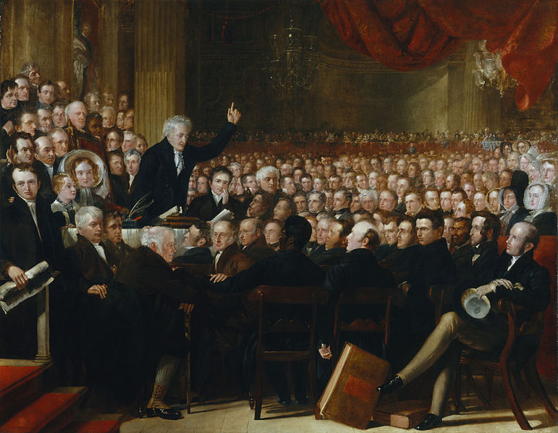
The World Anti-Slavery Convention met for the first time at Exeter Hall in London, on 12–23 June 1840. It was organised by the British and Foreign Anti-Slavery Society - a descendant of the Society for the Abolition of the Slave Trade - and coordinated campaigning against Slavery outside of the British Empire
The Anti-Slavery Society Convention, 1840 – A painting by Benjamin Robert Haydon

1849 Carlyle's essay "Occasional Discourse on the Negro Question" is first published

Source J: Carlyle, T. (1849) Occasional Discourse on the Negro Question
https://cruel.org/econthought/texts/carlyle/carlodnq.html
But, thank heaven, our interesting black population equaling, almost, in number of heads, one of the ridings [areas] of Yorkshire, and in worth (in quantity of intellect, faculty, docility, energy, and available human valor and value), perhaps one of the streets of seven dials* --are all doing remarkably well.
…How pleasant to have always this fact to fall back upon; our beautiful black darlings are at last happy; with little labor except to the teeth, which, surely, in those excellent horse-jaws of theirs, will not fail!
Exeter Hall, my philanthropic friends, has had its way in this matter. The twenty millions, a mere trifle, despatched with a single dash of the pen, are paid; and, far over the sea, we have a few black persons rendered extremely "free" indeed. Sitting yonder, with their beautiful muzzles up to the ears in pumpkins, imbibing sweet pulps and juices; the grinder and incisor teeth ready for every new work, and the pumpkins cheap as grass in those rich climates; while the sugar crops rot round them, uncut, because labor cannot be hired, so cheap are the pumpkins; and at home, we are but required to rasp from the breakfast loaves of our own English laborers, some slight "differential sugar duties." and lend a poor half million, or a few more millions, now and then, to keep that beautiful state of matters going on.
…beautiful blacks, sitting there, up to the ears in pumpkins, and doleful whites, sitting here, without potatoes to eat; never, till now, I think, did the sun look down on such a jumble of human nonsenses.

- What is Carlyle explicitly saying the worth of Black people is with this comment?
- What comparison / imagery is Carlyle using of Afro-Caribbean people?
- What racist image does Carlyle paint of ‘Black Persons’ of the Caribbean?
- What is the ‘nonsense’ Carlyle could be referring to and what does this imply his view on Slavery is?

1866 Royal Commission on Morant Bay

\In response to the controversy the previous year, a 'Royal Commission' examined 730 witnesses in the course of fifty-one days. Despite hearing and confirming the brutality of Eyre's response, the commission concluded that Jamaica had been saved by Eyre's "skill, promptitude and vigor". Public figures such as Thomas Carlyle, Dickens and John Ruskin vigorously defended Eyre. Others explicitly drew on emerging ‘scientific’ arguments of the ‘inferiority’ of Africans and their descendants. Abolition was, for many, to be regretted – and had been according to them carried out at the expense of the ‘White Poor’. The 'Eyre controversy' was the focus of great debate in England on race and the empire.

Source K : Punch.—December 23, 1865. The Jamaica Question. White Planter. “Am Not I a Man and a Brother, Too, Mr. Stiggins?”
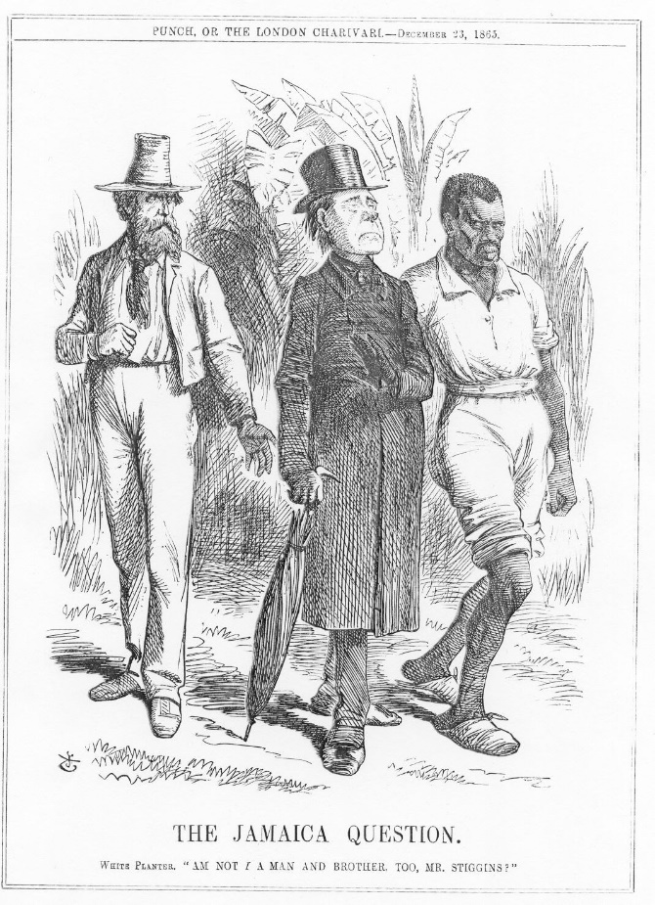
- Who do each of the three figures represent? How are they represented?
- What could this infer about British public opinion around abolition at the time?
- Why could this source have been produced in December 1865?
- How far can this tell us about British public opinion against slavery at the time?

