Source - Cruikshank's 1826 cartoon
Source - Cruikshank’s 1826 cartoon published in London. [England] : Published July 1826 by G. Humphrey, 24 St. James's Street, 1826.
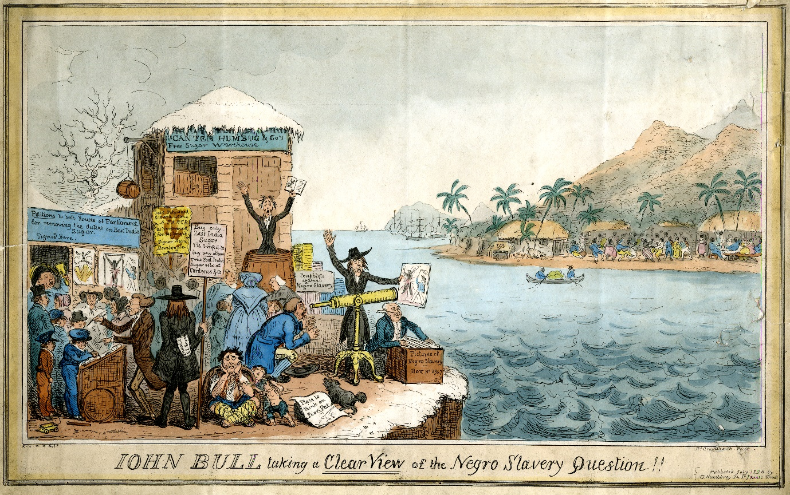
‘John Bull taking a clear view of the Negro Slavery Question, 1826’

This very detailed satirical cartoon by the cartoonist George Cruikshank presents a range of views common among opponents of the abolitionist cause. The cartoon is quite complicated but a closer look at various sections reveals the cartoonist's opinion about various aspects of the abolitionists' campaign. George Cruikshank (27 September 1792 – 1 February 1878) was a British caricaturist and book illustrator, praised as the "modern Hogarth" during his life. His book illustrations for his friend Charles Dickens, and many other authors, reached an international audience. Cruikshank replaced one of his major influences, James Gillray, as England's most popular satirist. For a generation he delineated Tories, Whigs and Radicals impartially. Satirical material came to him from every public event – wars abroad, the enemies of Britain (he was highly patriotic), the frolic, among other qualities, such as the weird and terrible, in which he excelled. His hostility to enemies of Britain and a crude racism is evident in a lot of his works.
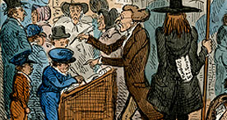
Here, various people are signing a petition - which was a common campaign method used by Abolitionists - in favour of removing duties on sugar originating in the East Indies. If the petition was successful, the likelihood that traders would purchase this sugar, rather than slave grown sugar from the West Indies, would increase. This would reduce the profits of those involved in the slave trade.
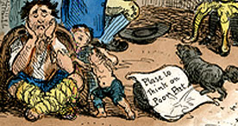
However, those signing the petition appear to be very young. Cruikshank is perhaps commenting on the validity of such petitions, particularly if the number of signatures is increased by those not able to vote.
Here, a man and his family can be seen begging. He is asking 'Please do think on poor Pat' though his spelling is incorrect.
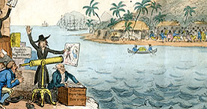
Here, Cruikshank is perhaps drawing a comparison between the poor and underprivileged people in British society and the slaves in the West Indies. He perhaps indicates that the abolitionists might look closer to home for cruelty and impoverished misery.
Here, an abolition campaigner obscures the view of another man who is looking through a telescope at an island. It seems that island life is rather idyllic while the image the Abolitionist wishes to portray is one of cruelty and misery.
Cruikshank is perhaps commenting on the often distorted nature of campaign material, revealing its status as propaganda and indicating that the suppositions and statements of the abolitionist campaign are not necessarily to be believed.
Here, the man's placard indicates that British people should only buy East Indies sugar, that not produced by slave labour. However, it is clear to see that he is in the pay of the East India Company from the invoice in his pocket.
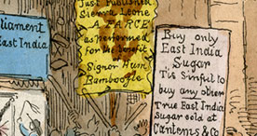
Cruikshank here reveals that not all campaigners' motives are grounded in ethics or morals.
Here, we can see an advert for a play. Both pro and anti-abolition campaigners used artists and writers to support their cause. However, this particular play has been given the title of 'Farce' and it is by a playwright called Signor Bamboozle. It would seem that Cruikshank is ridiculing the method of using artists and their work to promote a cause
https://www.bl.uk/learning/histcitizen/campaignforabolition/sources/antislavery/johnbullcartoon2/jbullcartoon.html

