Source
Hints to the young Jamaica Sugar Planter. By Robert HIBBERT (London: T & G Underwood, 1825), pp. 5-8.
https://books.google.co.uk/books?id=BwXFDd6WHHoC&pg=PP3&lpg=PP3&dq=robert+hibber+hints+to+a+young+jamaican+planter&source=bl&ots=rqoerWJrYk&sig=ACfU3U0uR0yCXQQ5xcYk-gFH8xctuOWIrw&hl=en&sa=X&ved=2ahUKEwiPtI6w2KfkAhWRecAKHVoABvkQ6AEwAHoECAkQAQ#v=onepage&q&f=false
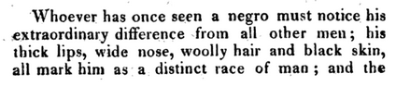
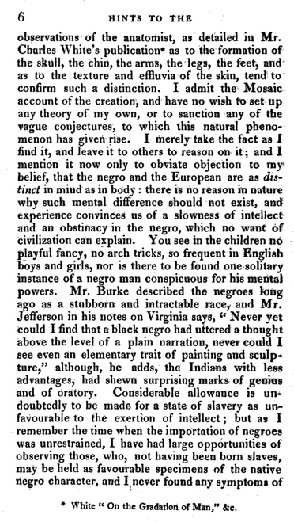

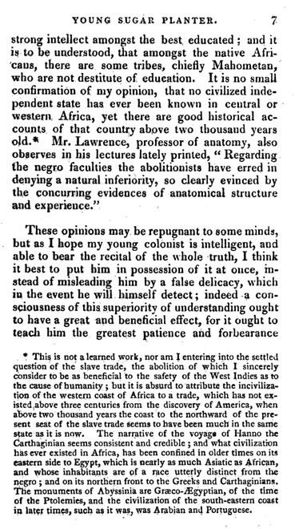
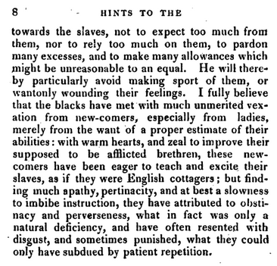

- How does the author construct race? Think about both biological and cultural hierarchies of racial difference?
- How does the author create a sense of his own knowledge and expertise? Why does this matter? Think about the text in relation to both the abolition campaigns and also as a signifier for the author’s own cultural identity.

